



**Name : KAVASKAR S**

**Stream : IV MCA-B**

**Reg No : 2347230**

**Cloud computing**

**Lab-2**

1. **Describe IaaS**

IaaS (Infrastructure as a Service) in AWS is like renting a virtual data center. Instead of buying and managing your own servers, storage, and networking equipment, you provision these resources in the cloud on a pay-as-you-go basis. This frees you from upfront costs and allows you to scale your resources up or down quickly to meet your application's needs. AWS offers a wide range of IaaS services, including:

* **Amazon EC2 (Elastic Compute Cloud):** Provides virtual servers with various configurations (CPU, memory, storage) to run your applications.
* **Amazon S3 (Simple Storage Service):** Highly scalable object storage for any type of data, from backups to website content.
* **Amazon EBS (Elastic Block Store):** Block-level storage for attaching high-performance disk volumes to your EC2 instances.
* **Amazon VPC (Virtual Private Cloud):** Lets you create a logically isolated network segment within the AWS cloud for secure deployment of your resources.

1. **List the Compute and Storage services available in AWS and GCP.**
   1. **Compute**
      1. **AWS:**
         1. **Amazon EC2 (Elastic Compute Cloud):** The core compute service, offering a vast selection of virtual machine configurations for diverse workloads. You have full control over the operating system and instance settings.
         2. **AWS Lambda:** Serverless compute service ideal for short-lived tasks triggered by events. You only pay for the resources your code consumes, making it cost-effective for spiky workloads.
      2. **GCP:**
         1. **Google Compute Engine:** Similar to EC2, offering virtual machines with various configurations. GCP integrates well with other Google Cloud services.
         2. **Google Kubernetes Engine (GKE):** Managed Kubernetes service for deploying and managing containerized applications. GKE simplifies container orchestration, a complex task in traditional deployments.
   2. **Storage Services:**
      1. **AWS:**
         1. **Amazon S3 (Simple Storage Service):** Object storage designed for scalability and durability. Ideal for storing large datasets, backups, and static website content.
         2. **Amazon EBS (Elastic Block Store):** Block storage for attaching high-performance disks to EC2 instances. EBS provides persistent storage for applications that require frequent disk access.
      2. **GCP:**
         1. **Google Cloud Storage:** Similar to S3, offering object storage for various data needs. Integrates seamlessly with other GCP services.
         2. **Google Persistent Disk:** Block storage for persistent data attached to virtual machines in Google Compute Engine. Offers similar functionality to Amazon EBS.
2. **Create 2 Identical AWS EC2 Instances (Instance Name: Regno_EC2_VM1,** **Regno_EC2_VM2) and install the necessary packages to execute a program of your choice in ‘Regno_EC2_VM1’.**

STEPS:

* 1. Login to Learner Lab

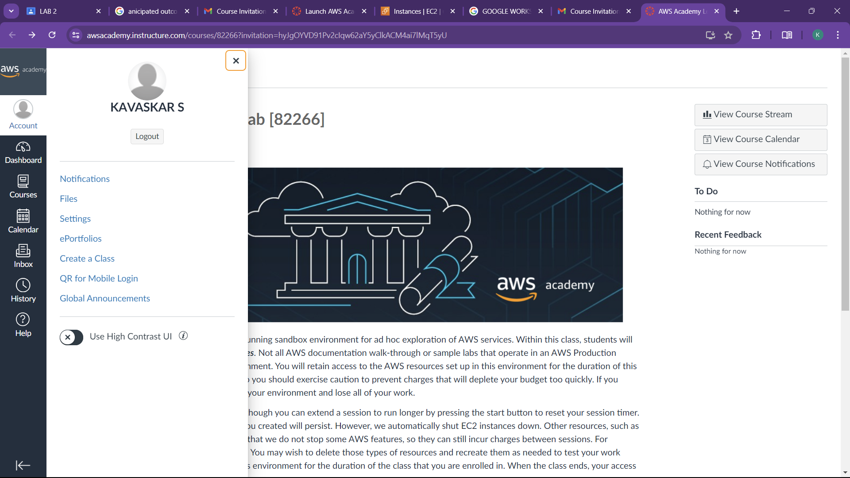

* 1. Launch Learner Lab

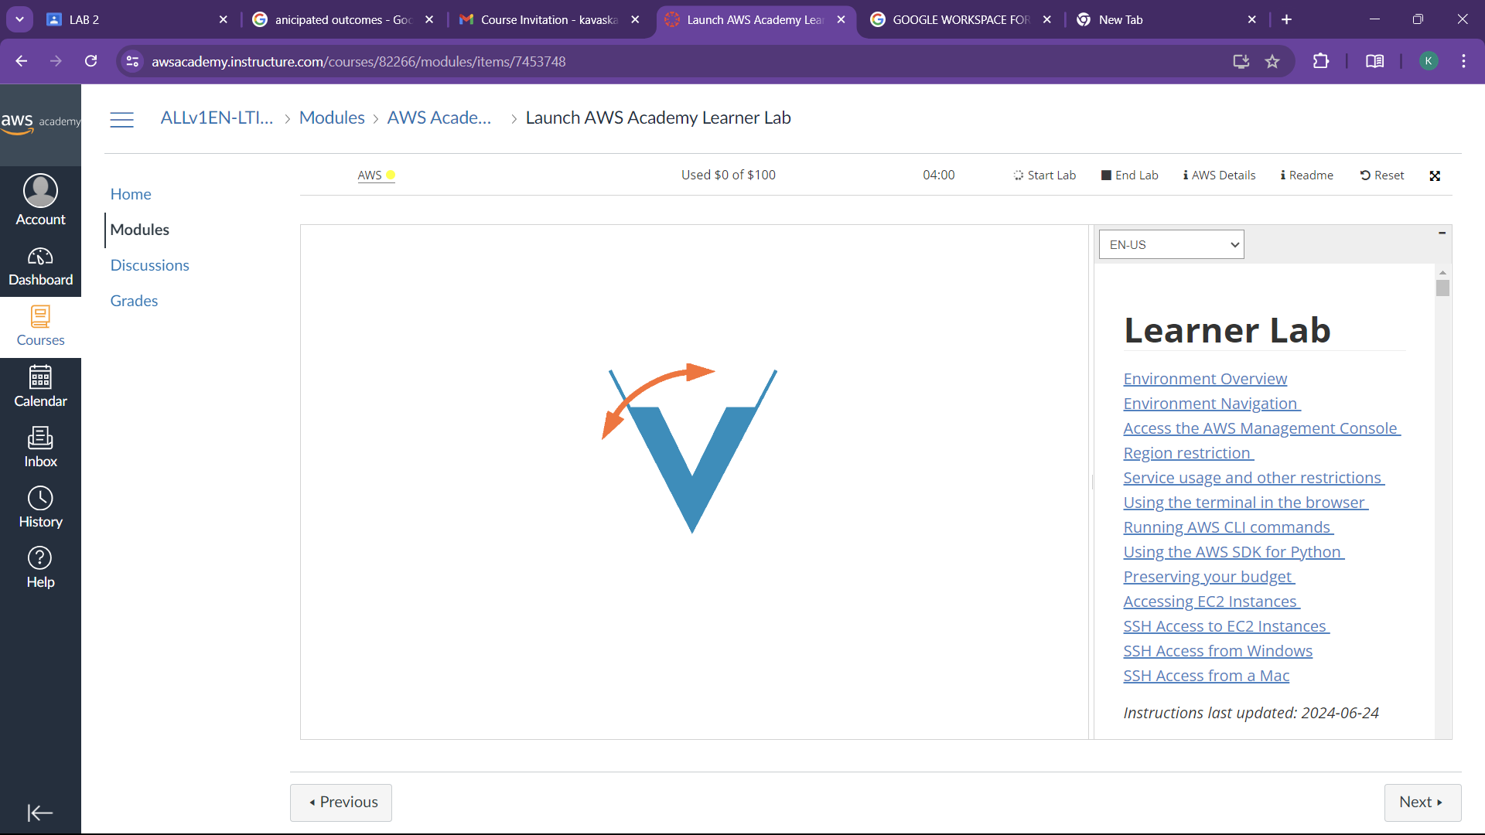

* 1. Go to services and Select EC2

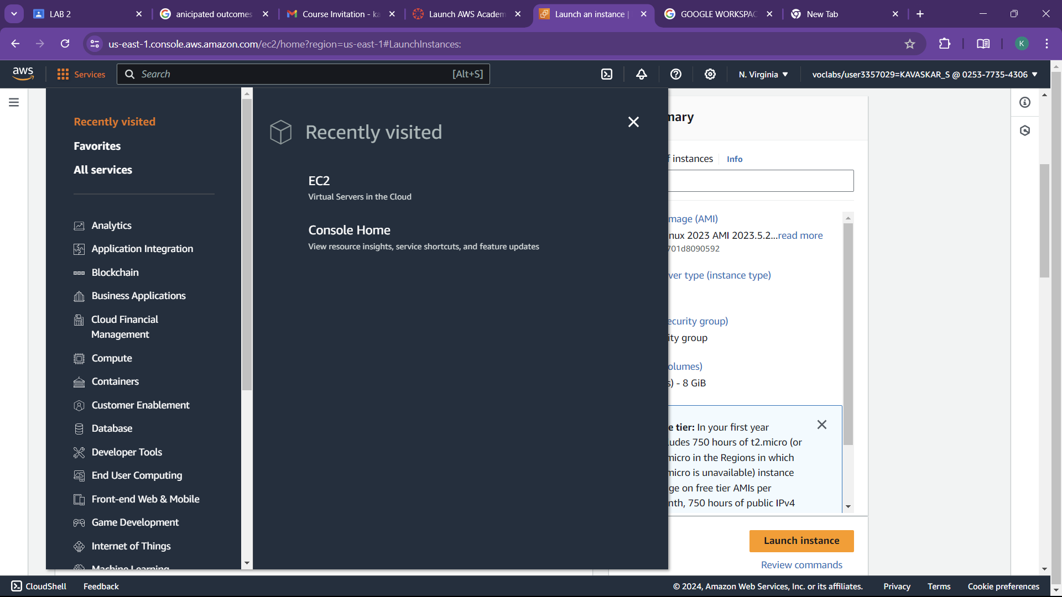

* 1. Give a name to the instance and select further options

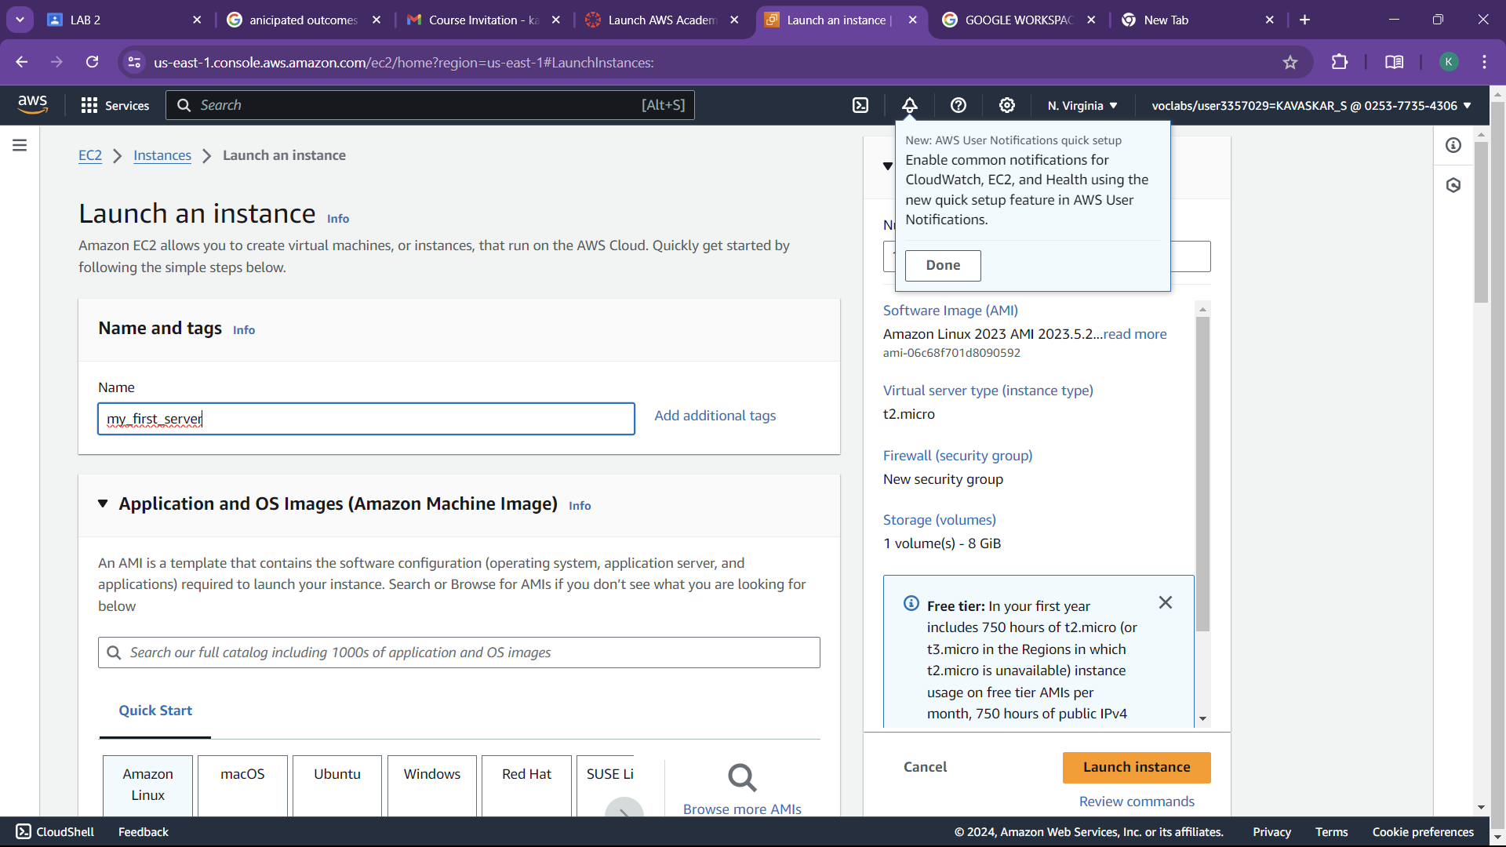

* 1. Click Launch instance to create to create a instance

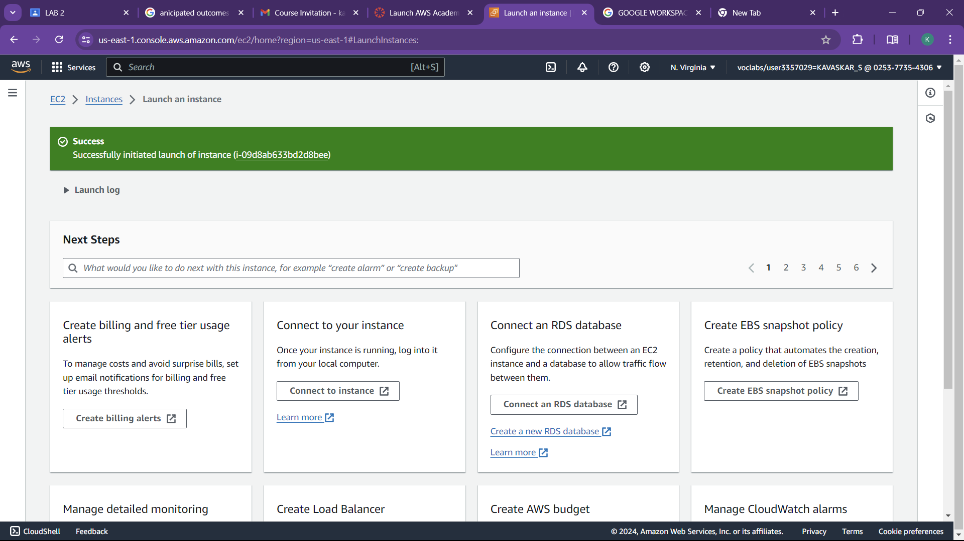

* 1. Finally go the instance dashboard to see the list of instance created

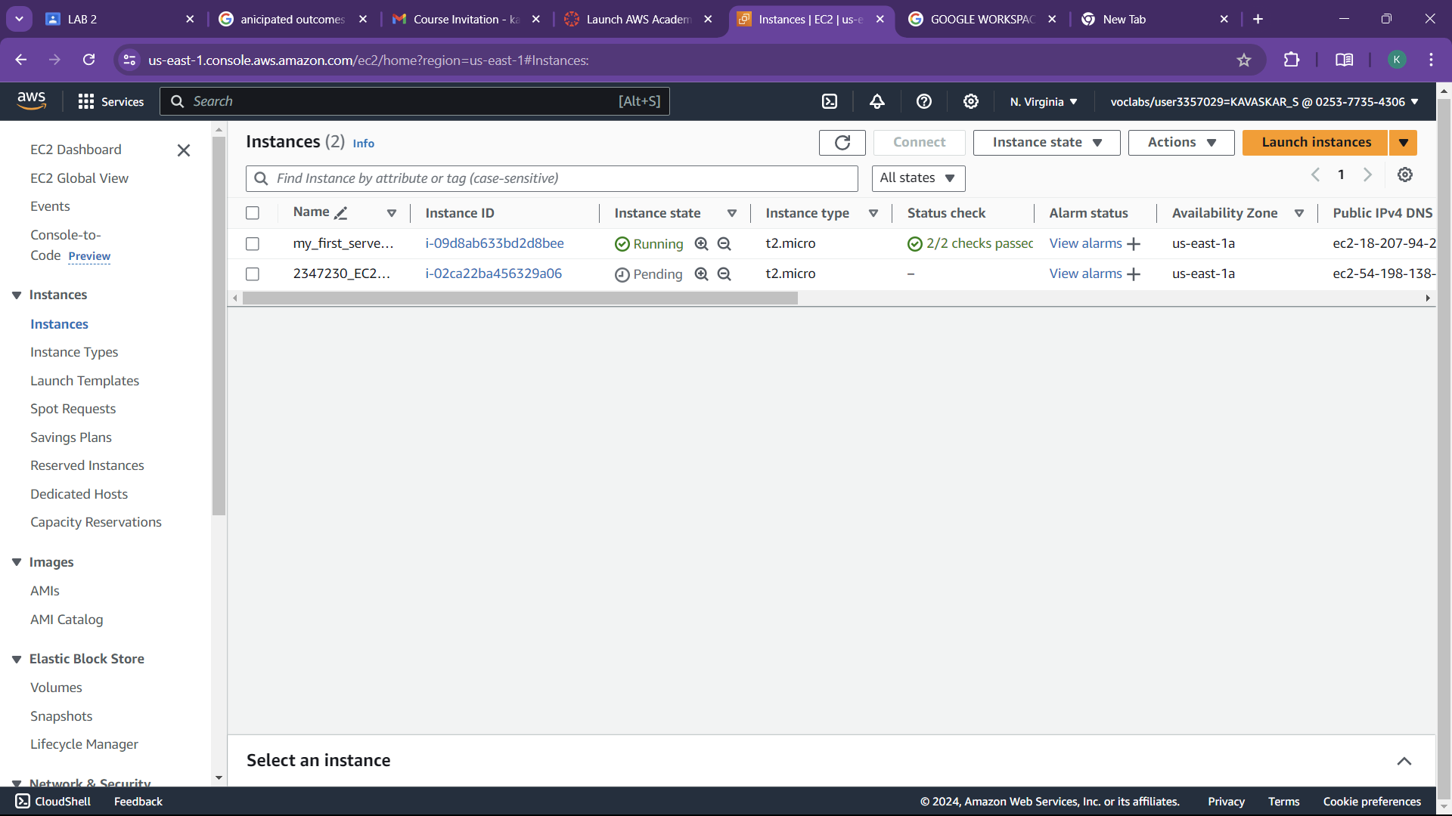

1. **Configure a Webserver on ‘Regno_EC2_VM2’ Instance and host your organizations website (Static Website) and provide access only to your machine.**

1.created the new instance 2347230_EC2_VM2

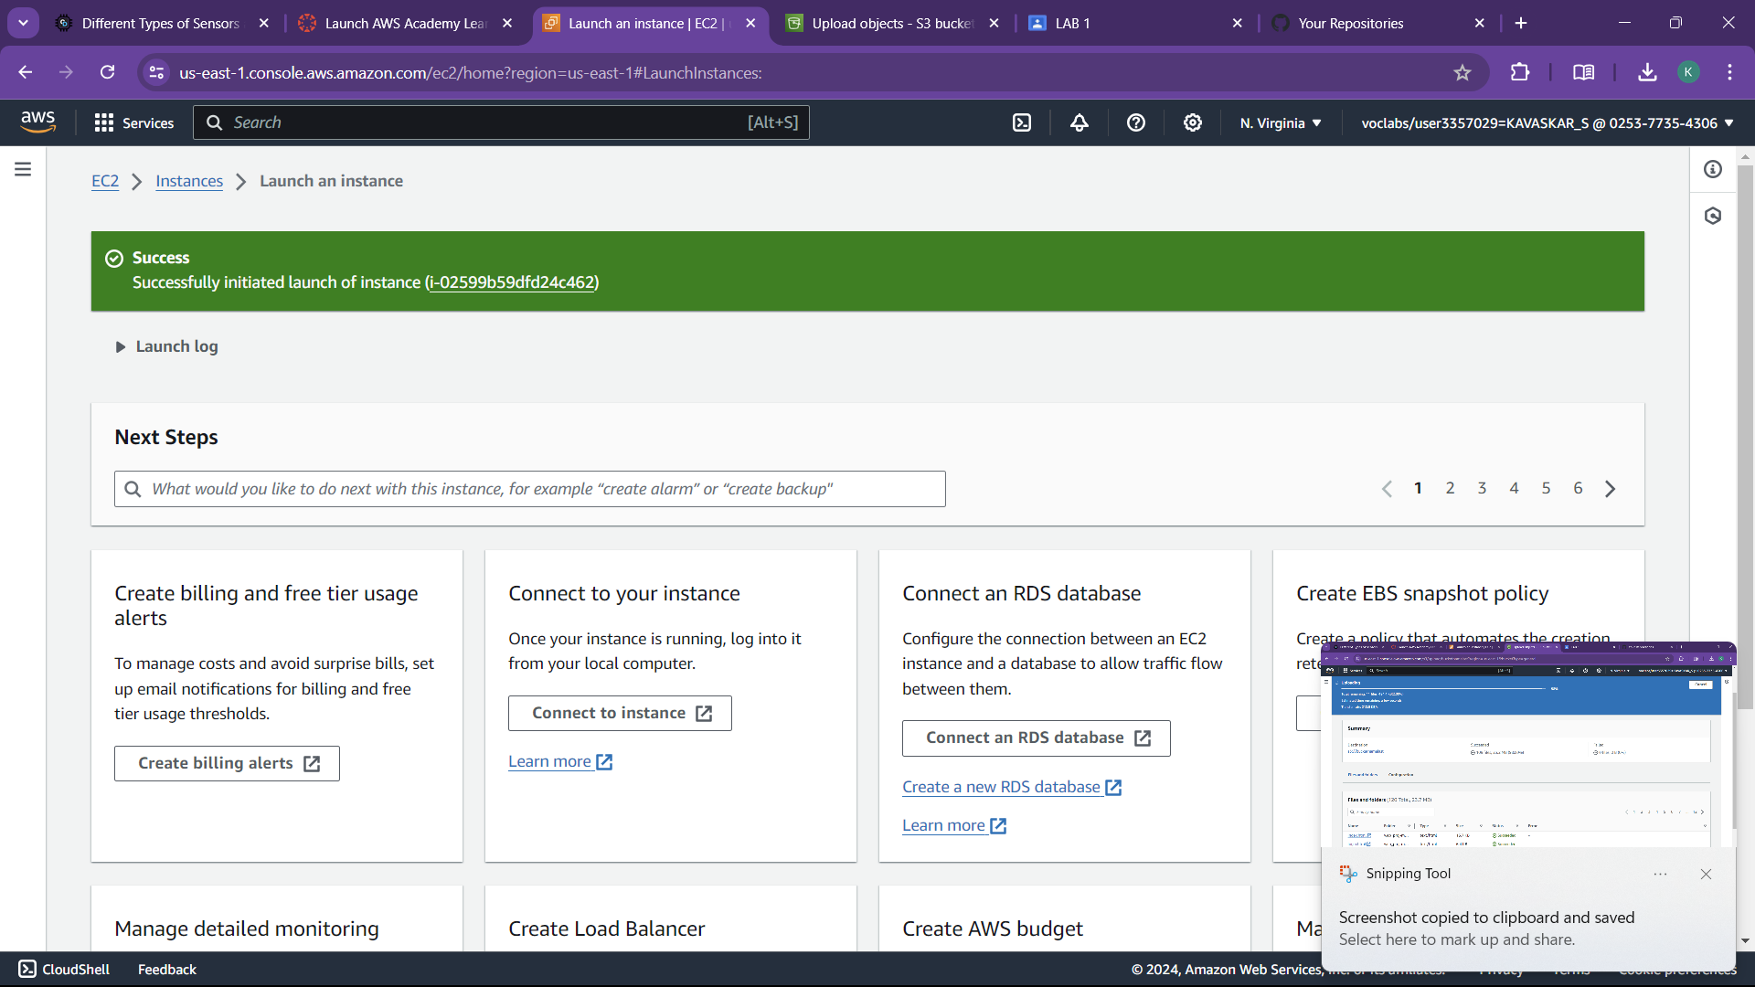

2.created bucket to store the files and uploaded files from the local storage

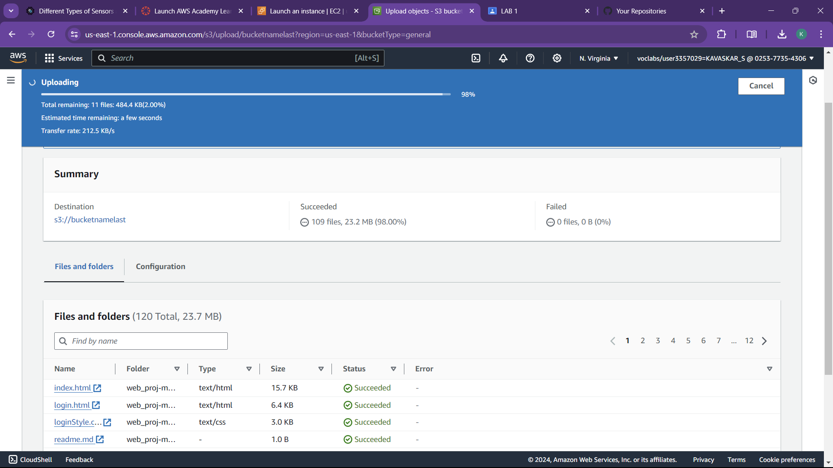

3.by clicking action and public ACL we will get the url

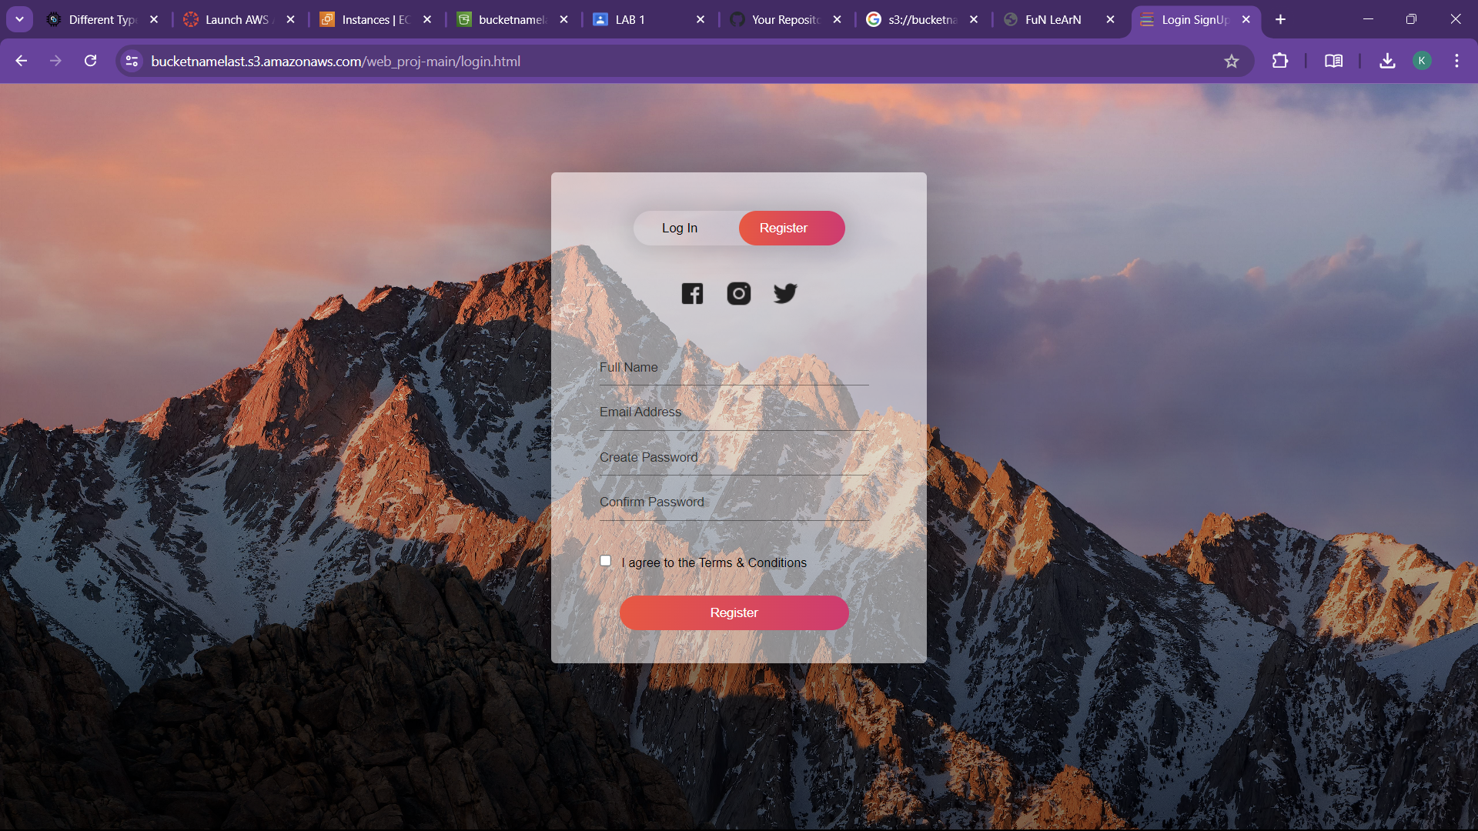

4.finally run one python program in the instance that we created and from this instance will be used later uses

